UNIT ONE and Important Documents
Mr. Clendenning
6th Grade Social Studies

Table of Contents
Mr. Clendenning

- Table of Contents…………………….
- Units of Study...................................
- Social Studies Contract.........................................
- Emergency Contact Information Sheet
- Day ONE of School-......................................
- Classroom Procedures and Laws............

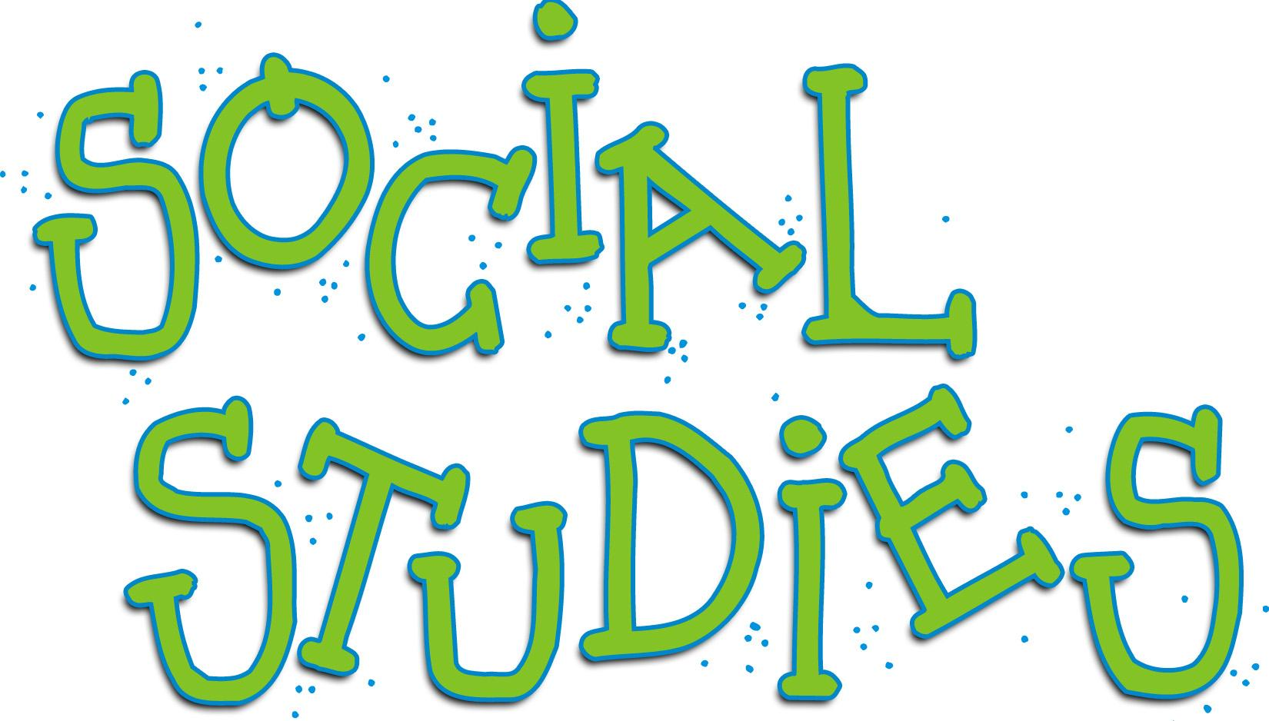
Unit One: Introduction of Social Studies
- What is Social Studies..............
- What is History........................................
- Primary Source vs. Secondary Source....

Units of Study

Unit One: Introduction of Social Studies
Unit Two: Geography & Features of civilization
Unit Three: Development of Civilization Mesopotamia, Egypt-Early River Valleys
Unit Four: World Religions
Unit Five: Classical Civilization and Forms of Government- Greece
Unit Six: - Rome
Unit Seven: Conflict- Civilizations in decline-
Middle Ages
Unit Eight: Cultural Interactions

6th Grade Social Studies Contract
GRADE BREAKDOWN
  - Tests 30%
  - Projects 30%
  - Quizzes 20%
  - Homework 10%
  - Class work 5%
  - Portfolios 5%

PROJECTS:
- Late projects: 5 points everyday it is late.
- Students will be given class time to work on their projects

TESTS:
- Will be given after completion of unit of study.
- They will be announced one week in advance and will be given a review sheet
- Students will use their notebooks, quizzes and homework/class work to prepare

QUIZ:
- Vocabulary quizzes will be given as needed (dates may vary)

HOMEWORK:
- Is assigned as needed to review class material
- If a student is absent, they must complete the work and it must be shown to the teacher one day after the day(s) they were absent

CLASSWORK AND PARTICIPATION
- Students earn a possible 5 points each day for class work AND participation
_ _ _ _ _ _ _ _ _ _ _ _ _ _ _ _ _ _ _ _ _ _ _ _ _ _ _ _ _ _ _ _ _
Student’s signature:

Parent’s signature:

6th Grade Contact Information
Student Name:
- Parent and/or Guardian Name:____________________________________

- Best phone number to reach parent/guardian: _______________________

- Best email to reach parent or guardian: ______________________________

_ _ _ _ _ _ _ _ _ _ _ _ _ _ _ _ _ _ _ _ _ _ _ _ _ _ _ _ _ _ _ _ _

DAY ONE OF SCHOOL- CLASSROOM PROCEDURE & RULES

- Line up in two lines outside the classroom______

- Sit in your assigned seat ________ (today you will be given assigned seats)

- Homework:
Get sixth grade social studies contract signed by parent and/Get class supplies : Green Folder, Green Notebook, Green Three Ring Binder
(copy into planners)

4: Date___________

5. AIM:(copy form the board) :

_____________________________________________________________

_____________________________________________________________

6. DO NOW: Copy the aim, date and then sit and wait silently for the teacher to begin.

Classroom Procedures and Laws

Classroom Procedures
Below are a list of classroom procedures.

Come to class prepared with green notebook, green folder and green three ring binder________
Get into two lines outside the classroom______
Sit in your assigned seat ________
Homework: (copy into planners)
Write down today’s date
Write down today’s AIM
Do the Do NOW

Classroom Laws
-Never get out of your seat without permission.
-Never talk when I or a classmate is speaking.
-Never talk back to teacher or peers.

Jobs for classroom-
All jobs must be applied for with a written note from student explaining why they would be the best candidate for the job. *** All jobs are for one month.
Planner signer-
Phone operator- Answer the phone.
Paper Passer-

Unit One: Introduction of Social Studies
Unit Description
This unit introduces students to the historical thinking skills and argumentative writing style that they will employ in all future units. Students will be introduced to the concepts of corroboration, perspective, contextualization, sourcing, and motive as they learn how to construct academic arguments using claim, reasons, evidence, analysis, and counterclaims.

Unit Compelling Questions
- What are the Social Sciences.
- What is History
- How is history written?
Unit Supporting Questions
- What is history?
- How do historians construct historical narratives?
Unit Conceptual Understandings

To interpret the past, historians use analytical techniques like corroboration, contextualization, and sourcing, and they weigh the perspectives and motives of historical actors.

Historians use research questions to guide their investigation of the past and answer theses questions by constructing academic arguments comprised rooted in a claim that is supported by reasons and evidence. They address counterclaims to strengthen their argument and to anticipate readers’ questions and objections.

Objectives:
- Students will be able to define: The Seven Social Sciences.
- SWBAT (Students will be able to) define history.
- SWBAT identify components of historical thinking
  - SWBAT define history.
  - SWBAT explain why history is subjective.
  - Students will understand 5 themes of geography

UNIT TWO

Geography and the DEVELOPMENT OF CIVILIZATIONS:
The development of agriculture enabled the rise of the first civilizations, located primarily along river valleys; these complex civs were influenced by
by geographic conditions and shared a number of defining political, social, and economic characteristics.
(Standards: 2, 3, 4; Themes: TCC, GEO, ECO, TECH)

Unit Compelling Questions
- What makes a civilization advanced?

Unit Supporting Questions
- Were humans better off before or after the Neolithic Revolution?
- How have humans adapted to and modified their environment to meet their needs?
- What makes a civilization a civilization?
- How did ancient civilizations shape global history?

Unit Conceptual Understandings

The Paleolithic Era was characterized by non-sedentary hunting and gathering lifestyles, whereas the Neolithic Era was characterized by a turn to
agriculture, herding, and semi-sedentary lifestyles.

Complex societies and civilizations adapted to and modified their environment to meet the needs of their population.

Complex societies and civilizations share common characteristics of religion, job specialization, cities, government,
language/writing systems, technology, and social hierarchy.

Complex societies and civilizations made unique cultural achievements and contributions.

What is Social Studies?
- Line up in two lines outside the classroom______
- Sit in your assigned seat ________
- Homework: Get class supplies : Green Folder, Green Notebook, Green Three Ring Binder (copy into planners)
- Put your name and date on the paper

AIM(copy from the board):
Do Now: After copying the board sit silently.

Anthropology:

History:

Sociology:

Psychology:

Political Science:

Economics:

Geography:

WHAT IS HISTORY?

AIM:
SWBAT define history.
SWBAT explain why history is subjective.

DO NOW: What is history?

CLASS NOTES
History is...

HISTORY IS SUBJECTIVE
SUBJECTIVE MEANS….
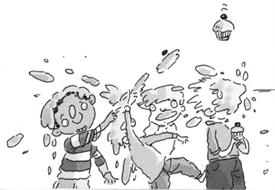
DIRECTIONS
Imagine that you are the principal of a school and you just found out that there was a food fight in the lunchroom during lunch. You’ve asked many students and teachers who witnessed the food fight what they saw so you can figure out who started it. Unfortunately, you have received many different accounts that disagree about who started the food fight, who was involved, and when it started. It’s important to remember that NO ONE is lying.

Questions
(1) How could there be different stories of the event if no one is lying?
(2) Who are the different people who might have seen this food fight? (Example: friends of those involved; people who don’t know the kids who were fighting; those who were fighting; teachers; students.)
(3) What might make one person’s story more believable than another person’s?

Exit Ticket FOR WHAT IS HISTORY

Why is there no such thing as just “one” history?

Primary and Secondary Sources

Identify whether the following sources are a primary or secondary source. You may reference your notes if you need assistance.

_____________________1. textbook

_____________________2. letter from WWI soldier about trench life

_____________________3. video footage of the fall of the Berlin Wall

_____________________4. Lesson on the Vietnam War

_____________________5. biography written by a college professor about Henry VIII

_____________________6. a painting by Leonardo da Vinci

_____________________7. a website about the Holocaust

_____________________8. a tape recording of an interview with a former slave about slavery

_____________________9. movie about Pearl Harbor

_____________________10. a vase from ancient Greece

11. Which of the following is the study of issues related to government?
a. economics b. sociology
c. political science d. anthropology

12. Which of the following is the study of people, their environment, and their resources?
a. history b. geography
c. irrigate d. sociology

Bonus question: Explain why either secondary or primary sources are more reliable when studying history.

CORROBORATION & SOURCING

AIM:
SWBAT define corroboration and sourcing.

PUT THE AIMS (LESSON OBJECTIVES) IN YOUR OWN WORDS

________________________________________________________________________________________________________________________________________________________________________________________________________________________________________________________________________

DO NOW: If there was a war between the United States and Germany, why might a historian want to look at both sides of an event before they decide what happened?

What do you think a German historian might say about who started the war? Why? What do you think an American historian might say about who started the war? Why?

Document 1

This lesson is about the skill of corroboration. Corroboration is the act of comparing pieces of evidence and seeing where they agree and disagree. When you have multiple pieces of evidence that say the same thing, your argument is stronger. When you only have one perspective on an event, you risk that it might be incomplete or maybe even wrong.

Historians corroborate evidence when they try to figure out what happened in the past. If they find multiple pieces of evidence that support their initial hunch, their case becomes stronger. If they can’t find enough evidence to support a particular argument about what happened in the past, they consider other explanations or interpretations.

Because the goal of corroboration is to build a strong argument, it also involves sourcing. You want to source for two reasons: (1) you want each piece of evidence to be reliable; and (2) you want to see if people with different perspectives agree about what happened. It’s always more convincing when two people who usually disagree happen to agree.

For example, a famous painting of the Battle of Lexington shows the American colonists standing their ground and fighting while the British fired on them. If you read the primary sources about the event, the Americans say the British fired first, and the British say the Americans fired first. So they disagree about who shot first. But both say the colonists scattered and ran away once the shooting started. So although we might not know who shot first, we can say with some confidence that the colonists did not stand their ground, despite the portrayal in the painting, because both sides agree on that point.
Source: Stanford History Education Group. Introductory Lesson: Make Your Case! California: Stanford University, 2013.

1. How can a historian strengthen their argument through corroboration?

2. Identify two reasons why historians source.
(1)

(2)

3. What can historians say with confidence happened during the Battle of Lexington? Why are they able to say this with confidence? What are they unable to say with happened with confidence? Why are they unable to say this with confidence?

